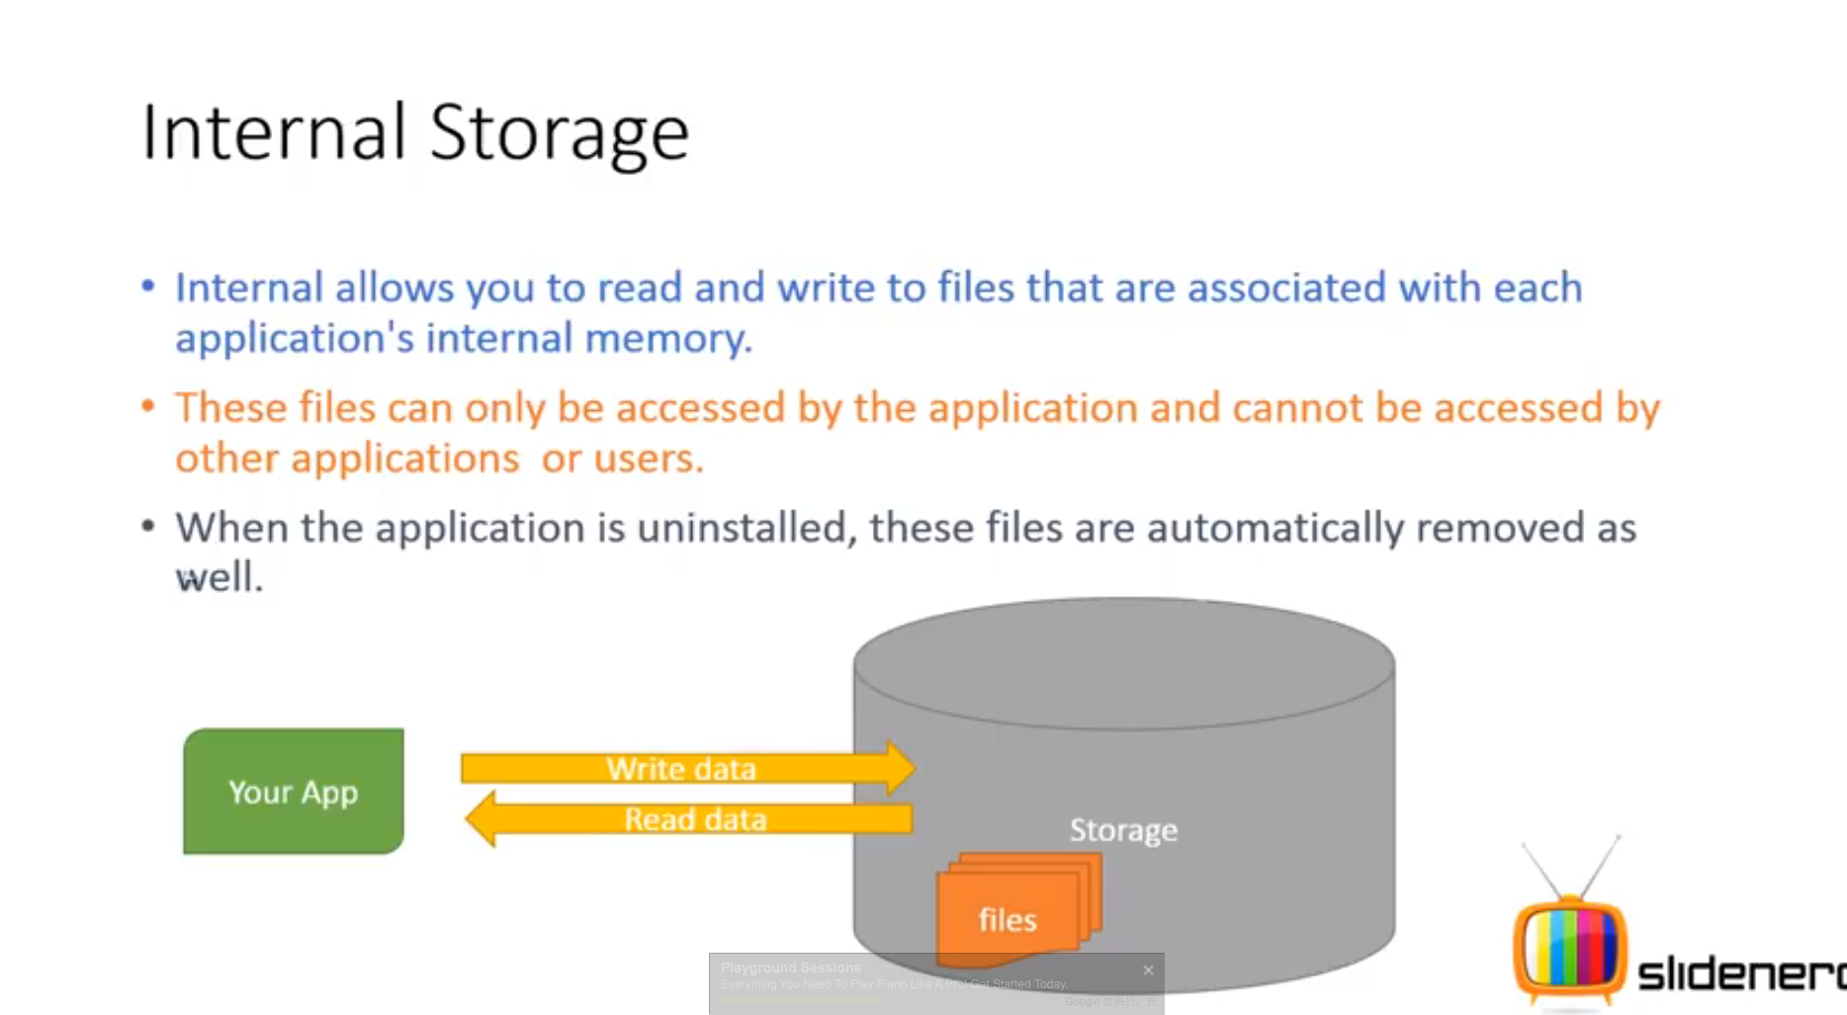

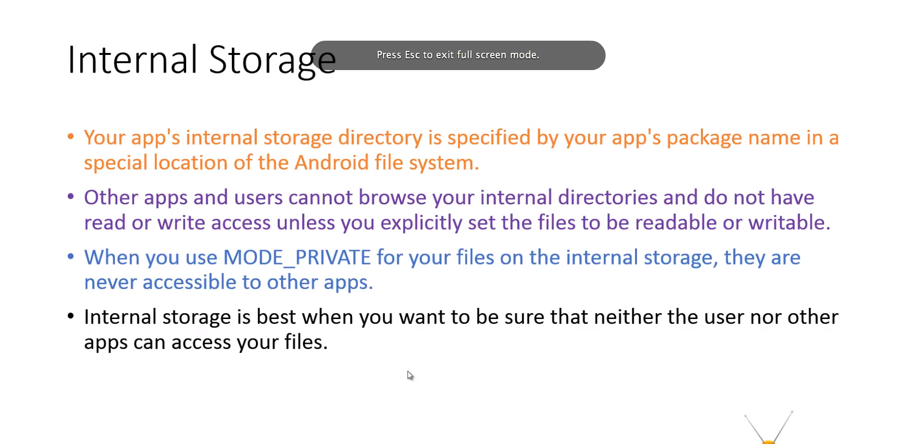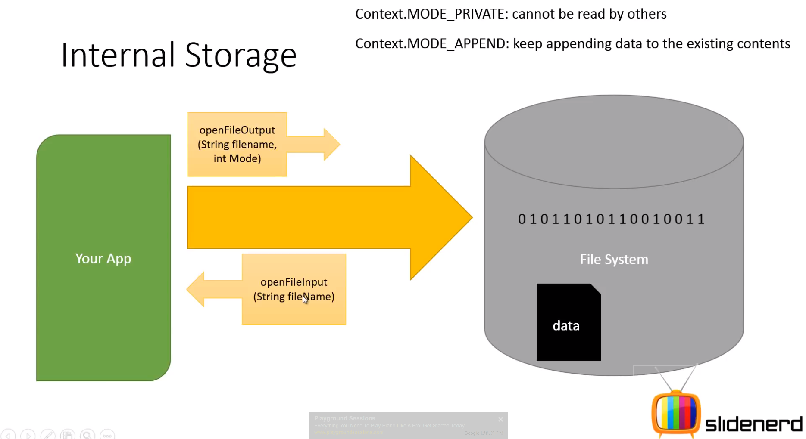

When using MODE_PRIVATE, existing content with the same filename will be replaced.

When using MODE_APPEND, new content will be appended to the existing ones.

File storage works with Bytes. Before insert it to stream, we have to serialize it. Vise versa when we read data out, we have to de-serialize it.

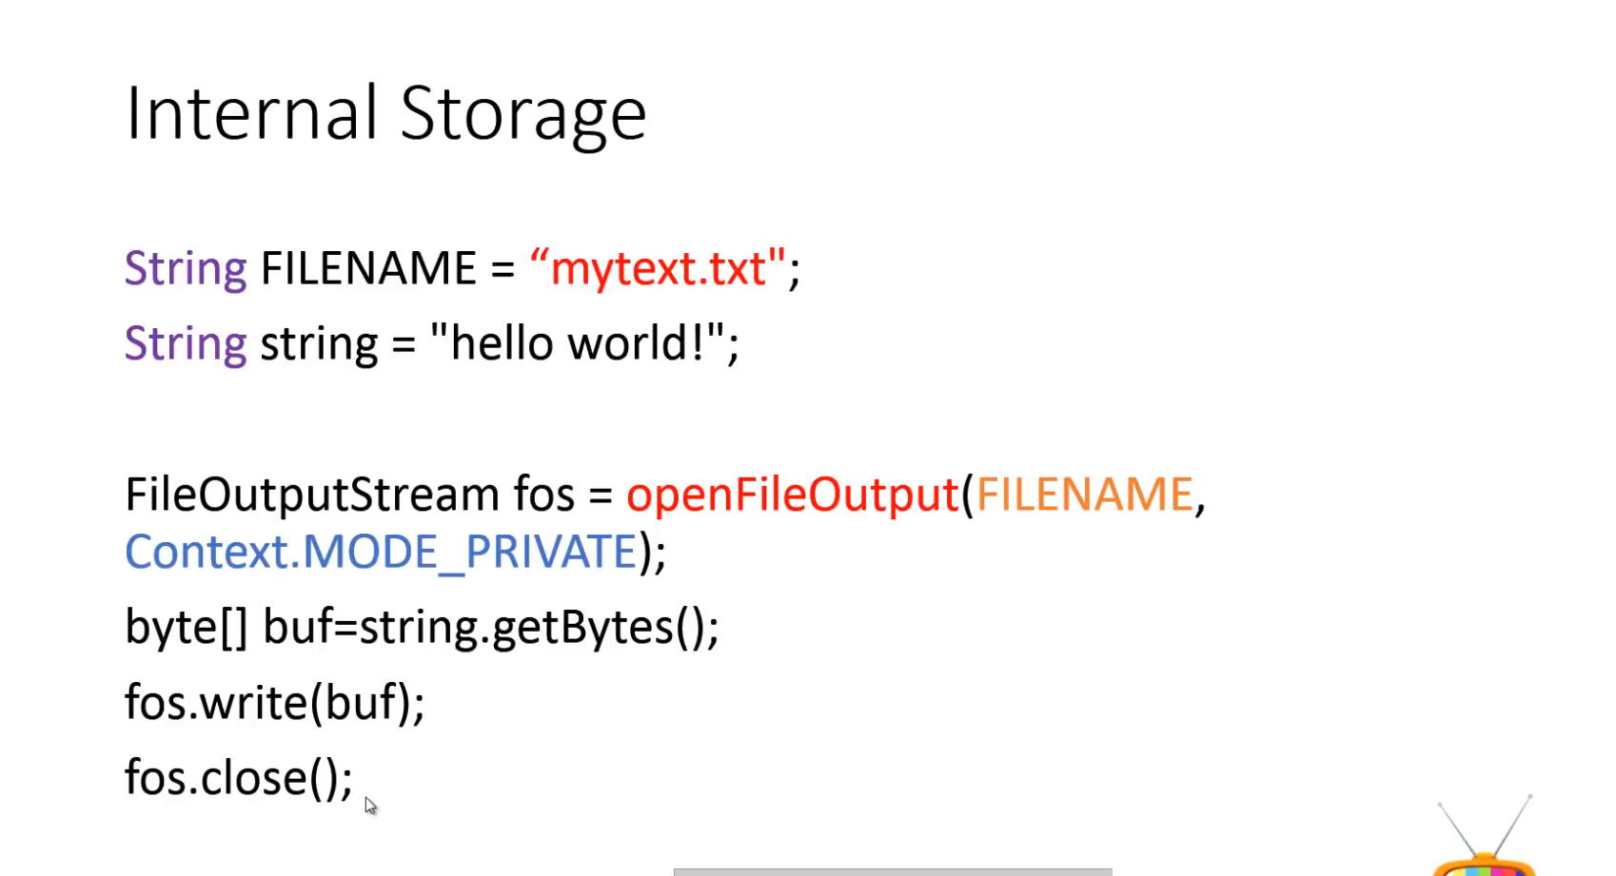

Example that we will work out in java code

